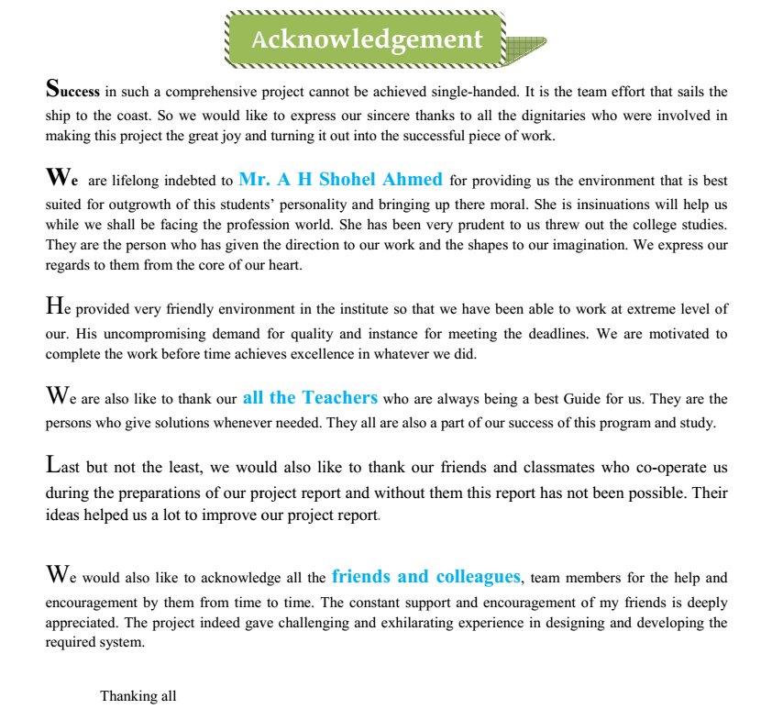

**Ruma Rani Das**

**UmmaHabiba Sharna**

**Asma Sadia**